RESUME
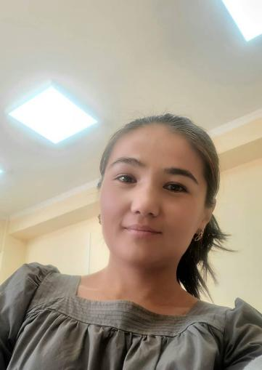 | - Sultanali kyzy Nurzada born in 1993-y.  - 2015 -y Finishes Kyrgyz-Russian Faculty  - Teacher foring language ( Chinese )  - General teaching experience
 | PERSONAL INFORMATION
Surname | Sultanali kyzy
Name | Nurzada
Date of born | 16.02.1993
Cantact numbers | Mobile phone | 0778150409
 | e-mail | Nurzadasultanalikyzy@gmail.com
 | Education
Start date / end date | Educational Institutation | Faculty | Spesialization
2010/2015 | OGPI | Kyrgyz -Russion | Teacher of Chinese language

