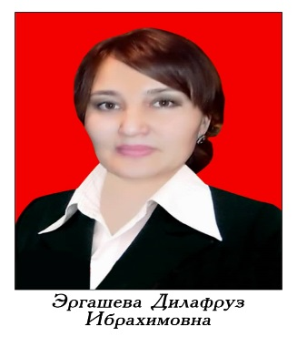
RESUME
ERGASHEVA DILAFRUZ IBRAHIMOVNA
Date of birth | - 19.02.1979
Nationality | - Uzbek
Family | - Married
Education | - Higher (1996-2001)
Educational Institution | - Jalal-Abad State University, Diploma with honors  - DV №251043
General experience | - 25 years
Pedagogical experience | - 25 years
Citizenship | - Kyrgyzstan
Awards | - Letter of appreciation of JASU ЖАГУ, 2010, Letter of appreciation of Philology Faculty, Certificate of honor of the City Council order No. 268-5 from 4.10.2021. Diplomas and certificates of JASU.
Computer skills | - Microsoft Word, Internet, Excel, Windows 2007,2008, 2010, Power point, Photoshop
Personal qualities | - Creative, responsible, honest, punctual
Hobbies | - Singing, cooking
Address | - Manas town, S. Akbarov street, №4/24
Phone | - (+996)705022970, (+996)220022970
Email | - edilafruza@mail.ru
Languages | - Russian, Kyrgyz, Uzbek, English, Turkish (intermediate)

