TURSUNBAEVA JAZGUL
Date of birth: |  | september 12, 1989 |  |  |  |  | 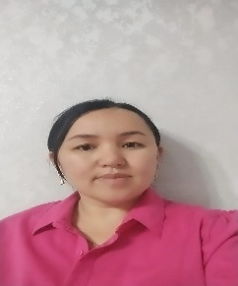
Contact information: |  | 0779667171  tursunbaeva12 @list.ru
Citizenship |  | Kyrgyzstan
Address |  | Jalal-Abad, Kurmanbek str. – 20/12
Teaching experience |  | 7 years
Education  Higher |  | Beginning studies:2008 y. |  |  | Еnding: 2013 y.
 |  | Educational institution |  |  | Jalal-Abad State University
 |  | Faculty |  |  | Faculty of Philology
 |  | Specialization |  |  | Teacher of the Kyrgyz language and literature
Work experience
The period of work |  |  | Organization |  |  | Position
2013 | 2015
 |  |  | Teacher of the R.Kuluev Ala-Buka Secondary School |  |  | Kyrgyz language teacher for primary classes
2017 | 2019 |  | c.Jalal-Abad channel Cholpon TV |  |  | staff department
2019 | 2022 |  | Jalal-Abad State University |  |  | Teacher of the Kyrgyz language and literature
2023 | 2024 |  | Jalal-Abad State University |  |  | Teacher of the Kyrgyz language and literature
2024 | Until now |  | I Jalal-Abad State University |  |  | Deputy Director of the Institute of Continuing Education
Additional information:
Marital status: married, has two sons and a daughter.
Office Applications:
Office Applications: |  |  |  | Microsoft Word, Internet.Exсel
Knowledge of languages: |  |  |  | Kyrgyz, Russian.

