RESUME
Mambetalieva Aigul Bozhuevna
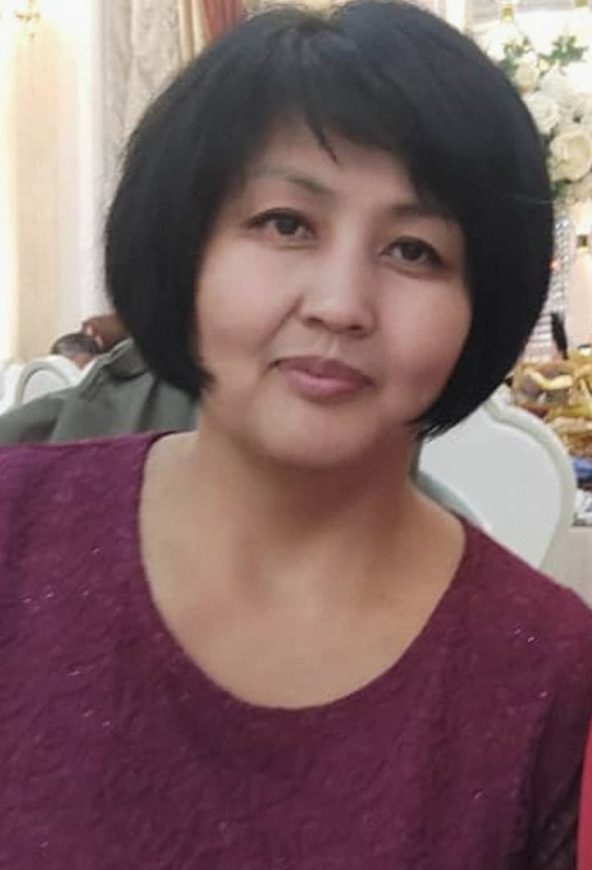 | - Mambetalieva Aigul Bozhuevna
 | - Jalal-Abad State University, specialty “Foreign language and literature”, 2000.
- ‘’Jalal-Abad State University named after B. Osmonov” Scientific-Educational and Industrial Complex.
Leading Specialist at the Testing Centre
Part-time Senior Teacher of the Department of English Language and Literature
 | - Teaching experience – 18 years, 18 years at Jalal-Abad State University named after B.Osmonov. The total experience -18 years.
 | PERSONAL INFORMATION
NAME | Mambetalieva
NAME | Aigul
NAME | Bozhuevna
DATE OF BIRTH | 26\09\.1977.
PHONE NUMBER | Mobile phone | 0222153742
 | E-mail | aigul26_77@mail.ru
 | EDUCATION:
Start/ End date | University | Faculty | Specialty
1995/2000. | Jalal-Abad State University | Faculty of Engineering and Pedagogy | «Foreign language and literature»
Diploma | Jalal-Abad State University | Qualification of a teacher in the specialty "English language" | Reg.number: #2155  17\0\2000  ГТ №05932
Diploma | Jalal-Abad State University | Qualification Certified specialist | Reg.number # 3554 26\04\2001.  ГВ №28265
WORK EXPERIENCE
Year of admission and dismissal | Organization | Faculty/Department | Position
2000-2001. | Jalal-Abad State University | Faculty of Foreign Languages, Department "Methods of teaching English" | Laboratory assistant
2001-2002 . | Jalal-Abad State University | Faculty of Foreign Languages, Department "Methods of teaching English" | Trainee teacher
2002-2010 | Jalal-Abad State University | Faculty of Foreign Languages, Department "Methods of teaching English" | Teacher
2006-2008. | Jalal-Abad State University | Department of Science and Postgraduate Studies, Faculty of Foreign Languages, Department "Methods of teaching English" | Head of the Postgraduate Department. Part-time teacher
2009-2013. | Jalal-Abad State University | Department of Quality and Educational work | Chief Inspector
2010-2013. | Jalal-Abad State University | Faculty of Foreign Languages, Department "Methods of teaching English" | Senior teacher
2010-2013. | Jalal-Abad State University | Department of Quality and Educational work | Secretary of the Educational and Methodological Council of JASU
2020-to the present | Jalal-Abad State University named after B.Osmonova | Faculty of Foreign Languages, Department "Methods of teaching English" | English Teacher
ADDITIONAL WORK
- Supervise the research work of the Department and the Faculty of Foreign Languages, 2004-2006.
- Supervise the educational and methodical work and Olympiads of the Department of Methodology and Theory of English Language, 2008-2009.
- Secretary of the meeting of the Department of Methodology and Theory of Teaching English, 2008.
- Responsible for the upbringing work of the Department of English Language and Literature, from 2021 -to the present.

TEACHING AND METHODICAL WORK
- Syllabus on discipline ‘Practical course of English language’, JASU, Jalal-Abad, 2003.
- Syllabus on the discipline ‘Home reading’, JASU, Jalal-Abad, 2005.
- Manual on discipline ‘Practical phonetics of English language’, 2024.
- Manual on discipline ‘Foreign language’, 2024.
RESEARCH WORK
• “Linguopragmatic Aspect of the Speech Act of ‘Congratulations’ in Kyrgyz, Hemshin, and English Languages,” NAUKOGRAD: Science, Production, Society, Scientific and Publicistic Journal, No. 4, Vol. 3, 2024, pp. 37–41, Russia.
• “Verbal and Nonverbal Behavior in Digital Communication: A Comparative Analysis of Kyrgyz and German Linguacultures.” Collection of Scientific Articles published by Springer, indexed in Scopus

PROFESSIONAL DEVELOPMENT (WORKSHOPS, SEMINARS, CONFERENCES).
- Certificate for participation in workshop for Teaching Development (provided by Civic Education Project) Jalalabad, 2001;
- Certificate of completion “Critical Thinking through Writing and Reading”, Jalalabad, January-May, 2003;
- Certificate for participation “Professional Development: English Teacher Training Course” (28 hours’ workshop), Jalalabad, January-June, 2004;
- Certificate of completion Write Right (Training Course), Jalalabad, 2004;
- Certificate. Fourth Annual Central Asian Teachers of English Conference (Workshop for English teachers), Dushanbe, Tajikistan, June 24-26, 2005;
- Certificate English Teacher Training Workshop (two-week workshop), Jalalabad, 2006;
- Certificate of completion The Logos Teacher Training Workshop (two-week workshop), Jalalabad, 2006;
- Certificate. New Technologies in Teaching English, Workshop for English teachers, 2007;
- Certificate. The 6th Annual International Teacher of English Conference, Issyk-Kul, June 28-2-July, 2007;
- Certificate. Certificate of completion Teacher Training in Rural Communities workshop, Osh, Jalal-Abad, 2008;
- Certificate. The 5th Annual Forum Conference “Teaching English in a Multicultural Context Show and Share,” Osh, March 27-29, 2008;
- Certificate. Rural Teacher Training Project, March 2007 and December, 2008
- New Ideas for Technology and Technology, Naryn, 2009;
- Certificate.Совершенствование педагогического мастерства 1- ноябрь- 23- декабрь, “Ала-Тоо” Өнүктүрүү Борбору, 2011;
- Certificate. Разработка Национальной Квалификационной Рамки в высшем образовании Кыргызской Республики, Бишкек ш., 2011;
- Certificate.Проектирование Образовательных Программ на Основе Компетентностного Подхода, Ош ш.,2012;
- Certificate. Тренинг ‘Дистанционное обучение, кредитная технология на основе ECTS’, “Ала-Тоо” Өнүктүрүү Борбору, 2013;
- Certificate. Academic Writing for Research Workshop, Jalal-Abad, 2013;
- Certificate. Intensive thirty-hour series of teacher training sessions, May, Jalal-Abad, 2013;
- Certificate. Shaping the Way, We teach English, The Landscape of English Language Teaching, U.S. Department of State and University of Oregon’s Online Course, May 2014;
- Certificate. “Киберпедагога-это не про роботов, а про Вас” , онлайн мастер класс, 2020-ж., 3-декабрь -2021-ж. 28-январь, “Belgian Education Council” , Бельгия.
- Certificate. “Урок как лабиринт. Использование квест-технологии в обучении и воспитании школьников “ 2020-ж., 19-ноябрь, ООО “Директ -Академия”, онлайн вебинар, Москва ш.
- Certificate.” Создаем электронные уроки в Google классе” 2020-ж. 19-ноябрь, ООО “Директ-Академия”, онлайн вебинар, Москва ш.
- Certificate. “Современный код преподавателя”, Ракурс “Все для дистанционного обучения, онлайн-коммуникации, авторизации работы HR,” , онлайн вебинар, 2020-ж. 8-декабрь, Москва ш.
- Certificate. “Methods to create video lesson”, “Belgian Education Council”, онлайн мастер класс, 2020, 20-декабрь, Бельгия
- Certificate. “E-Learning technologies in teaching English” илимий усулдук онлайн семинар, 2020-ж., 3-декабрь, Жалал –Абад ш.
- Certificate. “Teacher Training in English Teaching Methodology”, 2020, July-December, Jalal-Abad.
- Certificate. “Окутуучулардын педагогикалык чеберчилигин жогорлатуу”, 2021, апрель-июнь, ЖаМУ, Жалал-Абад ш.
- Certificate. “2021 Teachers Helping Teachers Seminar”, September9-1, 2021
- Certificate. Training on Writing research papers and proposals”, December 6-7, 2021, December 23, 2021-January 23, 2022.
- Certificate.. “Basic Methodology and Assessment course”, KGTESOL ELTA, February-March, 2022.
- Certificate. Cambridge day with Greg Archer” February 24, 2022.
- Certificate.. “The Primary Training Program to improve Academic Professionalism and Student-centered Learning methods” Билим-Стандарт, Июнь-13-25, 2022.
- Certificate. “Санариптештрүү ыкмасы кыргыз, англис, немис тили сабактарында” семинар тренинг, Февраль, Бишкек, Жалал-Абад, 2022.
- Certificate. ‘TESOL Methodology 2022”, October 28-29, Osh, 2022.
- Certificate. “Өлкө таануунун актуалдуу маселелери жана сабакта заманбап ыкмаларды колдонуу менен кызыктырып өтүү” семинар, Бишкек, Жалал-Абад, 3.-15.04.2023.
- Certificate. «Цифровые навыки и компетенции» в обьеме 72 часа, Билим-Стандарт, Бишкек, 9.02.2024.
- Certificate. “Искуственный Интелект и Геймификация в образовании”, Билим-Стандарт, Бишкек, 29.01.2024.
- Certificate of completion “Teaching Educators in Kyrgyzstan”, Lalal-Abad, May 29-June 15, 2024
- Certificate. “120-Hour TESOL\TEFL Certificate”, 21\07\2024.
- Certificate. IELTS, #24KG501135MAMA009A, Бишкек, 04/12/2024

Computer literacy: Microsoft Word, Excel, Power Point
AWARDS
- - ‘Certificate of Honor’ of the Faculty of Foreign Languages, 2003.
- - ‘Certificate of Honor’ of JASU, 2007.
- - ‘Certificate of Honor’ of the Trade Union Organization of JASU, 2010.
- - ‘Certificate of Honor’ of the Ministry of Education and Science of the Kyrgyz Republic, 2012.
- ‘’Diploma ‘’ Faculty of Philology JASU, 2023.

EXTRA INFORMATION
- Translator, OSCE, during the presidential elections, Jalal-Abad, October, 2011
- Translator, OSCE, during the parliamentary elections, Jalal-Abad, October 2010.
PROJECTS
- Academic integrity among teachers, Jalal-Abad, 2004-2005;
- Rural Teacher Training Project, 2008.
Language skills
Kyrgyz, Russian, English, Uzbek.
Marital status : Married

