RESUME
Isabaeva Yrysgul Abdimanapovna
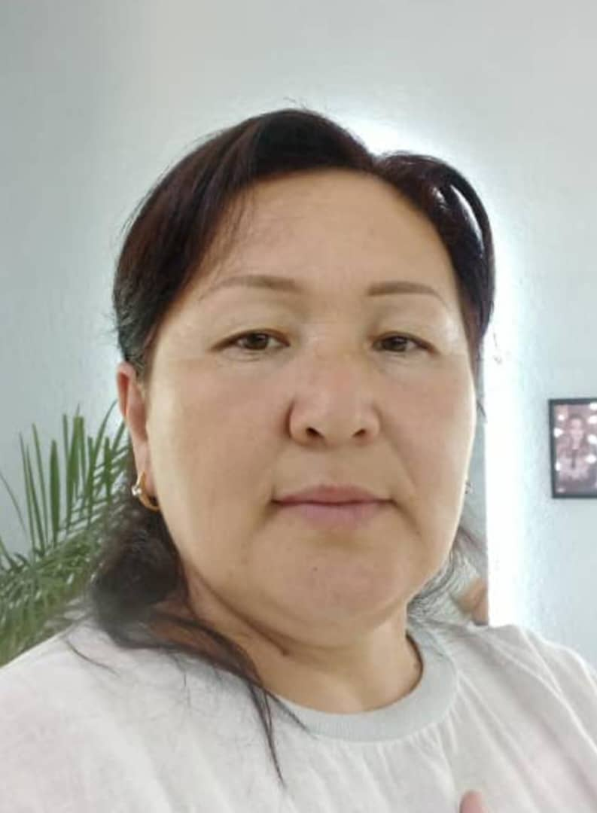 | - Isabaeva Yrysgul Abdimanapovna
 | - Jalal-Abad State University, specialty “Foreign language and literature”, 1995-2000.
 | - Senior Instructor of the Department of English Language and Literature
- Teaching experience 23 years, 20 years at Jalal-Abad State University named after B.Osmonov.
The total experience 23 years.
 | PERSONAL INFORMATION
NAME | Isabaeva
NAME | Yrysgul
NAME | Abdimanapovna
DATE OF BIRTH | 26.12.1978.
PHONE NUMBER | Mobile phone | 0773567942
 | E-mail | isabaeva.78@mail.ru
 | EDUCATION:
Start/ End date | University | Faculty | Specialty
1995-2000. | Jalal-Abad State University | Faculty of Engineering and Pedagogy | «Foreign language and literature»
Diploma | Jalal-Abad State University | Qualification of a teacher in the specialty "English language" | Reg.number: №2151  17.07.2000  ГТ №05851
Diploma | Jalal-Abad State University | Qualification Certified specialist | Reg.number:  № 3542 15.01.2001.  ГВ №28234
WORK EXPERIENCE
Year of admission and dismissal | Organization | Faculty/Department | Position
2000-2003 | Jalal-Abad Technical Institute | Department of English language | Instructor
2003-20011 . | Jalal-Abad State University | Faculty of foreign languages, Department “Methods of teaching English language”. | Instructor
2011-2015 | Jalal-Abad State University | Philology Faculty,  Department "English language and literature". | Instructor
2015-to the present | Jalal-Abad State University named after B.Osmonova | Philology Faculty,  Department "English language and literature". | Senior Instructor, Assistant director of Philology Institute
ADDITIONAL WORK
1. Management of the practice of the Department of English Language and Literature, 2012-2013
2. Responsible for the upbringing work of the Department of English Language and Literature, 2019-2021.

TEACHING AIDS (EDUCATIONAL AND METHODICAL WORK)
• Educational and methodical complex on the discipline "English sounds and intonation", JASU, Jalal-Abad, 2014.
• Educational and methodical manual on the discipline "Practical phonetics of the English language" JASU, Jalal-Abad, 2016
• Educational and methodical complex on the discipline “ Mass media ", 2017
• Educational and methodical complex “Grammatical and lexical materials for learning English”, Jalal-Abad, 2017
• Educational and methodical complex "Check your English", JASU, Jalal-Abad, 2017..
• Lecture course on the discipline "Language of Mass Media", JASU, Jalal-Abad, 2019
• Educational and methodical complex “Theoretical Phonetics", Jalal-Abad, 2019
• A course of lectures on the discipline “ Comparative Typology ”, Jalal-Abad, 2024
PROFESSIONAL DEVELOPMENT (WORKSHOPS, SEMINARS, CONFERENCES).
- Certificate for participation in workshop for Teaching Development (provided by Civic Education Project) Jalalabad, 2001;
- Certificate of completion “Critical Thinking through Writing and Reading”, Jalalabad, January-May, 2003;
- Certificate for participation “Professional Development: English Teacher Training Course” (28 hours’ workshop), Jalalabad, January-June, 2004;
- Certificate of completion Write Right (Training Course), Jalalabad, 2004;
- Certificate. Fourth Annual Central Asian Teachers of English Conference (Workshop for English teachers), Dushanbe, Tajikistan, June 24-26, 2014;
- Certificate.Тренинг для преподавателей: Workshop for Teaching Development (provided by Civic Education Project) Жалал-Абад, ноябрь, 2010
- Certificate.Professional Development: English Teacher Training Course (28 hours workshop), Jalalabat, January, 2013
- Certificate.Write Right (Training Course), Jalalabat, 2013
- Certificate.New Technologies in Teaching English? Workshop for teachers, Jalal-Abad, 2014
- Certificate.Teacher Training Sessions, Jalal-Abad May, 2013
- Certificate.Academic Writing for Research Workshop, Jalal-Abad, April, 2013
- Certificate.Syllabus Design Workshop, Jalal-Abad, March 2014
- Certificate.«Academic and professional Exchange programs» February , Jalal-Abad,2017
- Certificate.«Crossroads theater» training, February , Jalal-Abad, 2017
- Certificate.«Modern innovations in the world of English» May, Jalal-Abad, 2017
- Certificate. « Forum regional Summer camp» May, Osh,2017
- Certificate.Personal and professional development, May,Jalal-Abad,2017
- Certificate.Teachers helping teachers’’ September, Jalal-Abad,2016
- Certificate.Learning languages learning cultures’’ March, Jalal-Abad,2017
- Certificate.American English Webinar Series 4’’ December 2016 Online Course
- Certificate.American English Webinar Series 5’’ April 2017 Online Course
- Certificate. Certificate of completion Teacher Training in Rural Communities workshop, Osh, Jalal-Abad, 2008;
- Certificate. Academic Writing for Research Workshop, Jalal-Abad, 2013;
- Certificate. Intensive thirty-hour series of teacher training sessions, May, Jalal-Abad, 2013;
- International scientific-practical conference’’ May 22-30.2017 Prague
- Certificate. Shaping the Way, We teach English, The Landscape of English Language Teaching, U.S. Department of State and University of Oregon’s Online Course, May 2014;
- Certificate. “Teacher Training in English Teaching Methodology”, 2020, July-December, Jalal-Abad.
- Certificate. “Окутуучулардын педагогикалык чеберчилигин жогорлатуу”, 2021, апрель-июнь, ЖаМУ, Жалал-Абад ш.
- Certificate. “2021 Teachers Helping Teachers Seminar”, September9-1, 2021
- Certificate. “Өлкө таануунун актуалдуу маселелери жана сабакта заманбап ыкмаларды колдонуу менен кызыктырып өтүү” семинар, Бишкек, Жалал-Абад, 3.-15.04.2023.
- Certificate. «Цифровые навыки и компетенции» в обьеме 72 часа, Билим-Стандарт, Бишкек, 9.02.2024.
- Certificate. “Искуственный Интелект и Геймификация в образовании”, Билим-Стандарт, Бишкек, 29.01.2024.
- Certificate of completion “Teaching Educators in Kyrgyzstan”, Lalal-Abad, May 29-June 15, 2024
- Certificate. “120-Hour TESOL\TEFL Certificate”, 21.07.2024.

SCIENTIFIC ARTICLES:
- «Исследование методологических основ художественного перевода» Казахстан, Шымкент 2014г.
- «Critical thinking with language learners» Казахстан, Шымкент 2014г.
- «Перевод сказок как межкультурный диалог» БГУ, 2013г.
- «Teaching Pronunciation through songs» ЖАМУ, 2013г.
- «Teaching Writing Recount through Daily Activities» ЖАМУ, 2013г.
- «Особенности перевода сказочных имен в кыргызском и английском языках» МУК Бишкек, 2013г.
- «The semiotic analyses of the translation of the fairy tale Firebird.» МУК Бишкек, 2015г.
- «Rules and strategies for effective communication» ЭУП Жалал-Абад, 2017г.
- «Foreign languages in the course of modernization» Казахстан, Шымкент 2018г.
- «Critical thinking makes classes better» ЭУП Жалал-Абад, 2017г
- «Understanding and using American idioms in learning English languages» ЖАГУ, 2015г.
- «The problems of Listening and effective ways to solve them» ЖАГУ, 2015г.
- «Основные задачи художественного перевода» ЖАГУ, 2016г.
- «Влияния экономического роста на развитие образования» БГУ Бишкек. 2016г.
- «Education in modern time» Прага, 2017г.
- «Язык и культура 21-века» ЖАГУ, 2017г.
- «The English Language for Global Communication and Perspective of Youth» ЖАГУ, 2018г.
- «Using drama is an important source of teaching English in secondary schools» ЖАГУ, 2018г.
- «Linguocultural aspects of translation of Kyrgyz fairy tale “Clever boy” ЖАГУ, 2024г.

Computer skills: Microsoft Word, Excel, Power Point
AWARDS
- ‘Honor Certificate’ of the Trade Union Organization of JASU, 28.02.2014.
- ‘Honor Certificate’ of JASU, 07.03.2015
- ‘Honor Certificate ’ of the Trade Union Organization of JASU, 06.03.2017
- “Hero Mother medal” Kyrgyz Republic, 26.05.2023

Language skills
Kyrgyz, Russian, English, Uzbek.
Marital status : Married, seven children.

