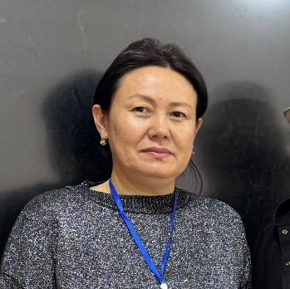
Sopukulova Aikokul Abdyrakmanovna
Cell: 0775-63-07-63
Email: Aikokul_abdrahmanovna@list.ru
Personal information:
Citizenship-Kyrgyz Republic
Address- Jalal-Abad, A.Kasymbekov st. # 42
Education- Higher. Jalal -Abad State University, faculty of foreign language, specialty -foreign language and literature .1999-2004y.
Date of birth-04.05.1983
Gender-Female
Marital status-Married, 3 children
Experience in projects:
2015-2018 Ministry of Education and Science of Kyrgyz Republic «Four skills in teaching and learning English Language»
2016-2018 Ministry of Education and Science of Kyrgyz Republic «Support for reforms in Education sector of Kyrgyz Republic» observer-coder.
2017 – National Testing Center under the Ministry of Education and Science of Kyrgyz Republic and the University of Virginia «Class Instrument» coder.
2022-2024- Ministry of Education and Science of Kyrgyz Republic, project “ Education for the future”- Master coder
Work experience in the specialty:
2004-2005 Head of the cabinet of Foreign language Department. JASU
2005-2021 foreign language teacher. Jalal-Abad College
Present time-Lecturer at the Department of Foreign Language and Literature

Additional education:
International ITEC Training Program on «Training Methodology for Development Professionals»
Indian Government.
Soros Kyrgyzstan «Critical Thinking in writing and reading
GIZ «Active forms of education»
UNDP «Developing Teacher Skills in conflict resolution and tolerance»
American association in Kyrgyzstan « Teaching writing skills»
Education for the future “Digital literacy”.
Languages: Kyrgyz, English, Russian.
Additional information: I confidently use Microsoft Word, Excel, and Power Point
I have a high degree of self- organization, social-emotional skills, I concentrate on the task, and I complete it on time.

